**Constructing the KPgolem Keypunch Interface**

Overview

This document describes the components and required functions of the keypunch interface, allowing the reader to build their own version. It does not specify exact parts and wiring for everything, permitting each builder to choose details as they see fit, but does describe a reference implementation.

A small set of modifications to the wiring of the keypunch must be done if you will use the functions to read cards and/or validate correct punching of cards. These involve swapping wires on two relays in the keypunch.

The interface control box is mounted inside the keypunch and a single DB9 cable is passed through the sheet metal frame of the machine at whatever point the builder chooses. This socket provides the RS-232 serial connection to the outside world.

The protocol over the serial link is designed for ease of diagnosis by humans and to support the widest variety of terminal programs or other hardware to link to this interface. Its default mode is ASCII.

The interface should be built inside some kind of enclosure, which will be installed inside the keypunch for operation. The reference implementation:

* Uses an Arduino Mega 2560 controller
* Uses two 8-relay boards that collectively provide 16 relays to switch keypunch circuits
* Uses an RS232 interface board to convert voltage levels between RS232 and TTL standards
* Uses a voltage regulator board to drive the relay boards power, offloading the Arduino power system
* Leverages a 12V power brick to convert the mains power of the keypunch to the input level of the Arduino and voltage regulator card
* The user connection is via a DB9 connector, using RS232 at 9600 baud, 8 bit no parity and 1 stop bit, software flow control via xon/xoff, and only uses RX and TX signals
* The connection to the keypunch mechanism is via two DB-25 connectors, one male and one female to prevent misconnections, allowing the box to be removed from its keypunch and potentially moved to other machines.
* Each keypunch circuit switched by a relay is given a fast diode, reversed polarity, hooked to keypunch ground to suppress arcs from the relays both in the keypunch and in this box
* Pins and female connectors were found that fit into the keypunch relay sockets and over the SMS board pins for the wiring cables that plug into the interface box
* Was built into a plastic project box that sits to the right of the keypunch relay panel
* The project box has two DB25 connectors for the wiring to the keypunch, a DB9 connector for the link to the user, and a barrel connector for the power brick to deliver its 12V supply.
* The USB link on the Arduino is only used to update the programming, thus no connector is provided on the outside of the project box. The box must be opened to process updates.
* The software is configured to use underscore as a delimiter, full verbs for most commands, and defaults to EBCDIC encoding on ASCII. Verification is off by default.
* Prototype shield hardware was used to connect the relay boards, serial board and connectors to the Arduino
* The software defines match the choice of Arduino pin for each signal wired to various boards and connectors
* The assignment of keypunch circuits to specific DB25 pins matches the wiring in place for the first generation interface used at the Computer History Museum, in order to simplify the upgrade of keypunches from that hardware to the KPgolem interface.

Keypunch models supported

This interface has been developed for the IBM 029 models using the relay panel, but should also work with 026 keypunches but the details of wiring the cables to the 026 are not fully validated yet. The reed relay models of the 029 have not been investigated yet, no wiring details are known and it is possible some functions are not achievable in the same way on those models, requiring design changes.

Keypunch modification to support card reading and verification

In order to make use of the read station of the keypunch, which is normally involved to duplicate the holes from the card in this station onto the card to its right in the punch station, we have to allow isolation of the contacts since our interface operates with 5V TTL voltage levels but the keypunch while duplicating passes 48V through the same contacts.

Relay 4, the leftmost relay on the logic gate when looking in from the rear of the keypunch, is called the DUP3 relay. To its right is relay 7, also called the DUP1 relay. These are the two relays whose connections we will modify. To make the change, we swing the logic gate outward and down so it sits parallel to the floor with the back of the gate now accessible.

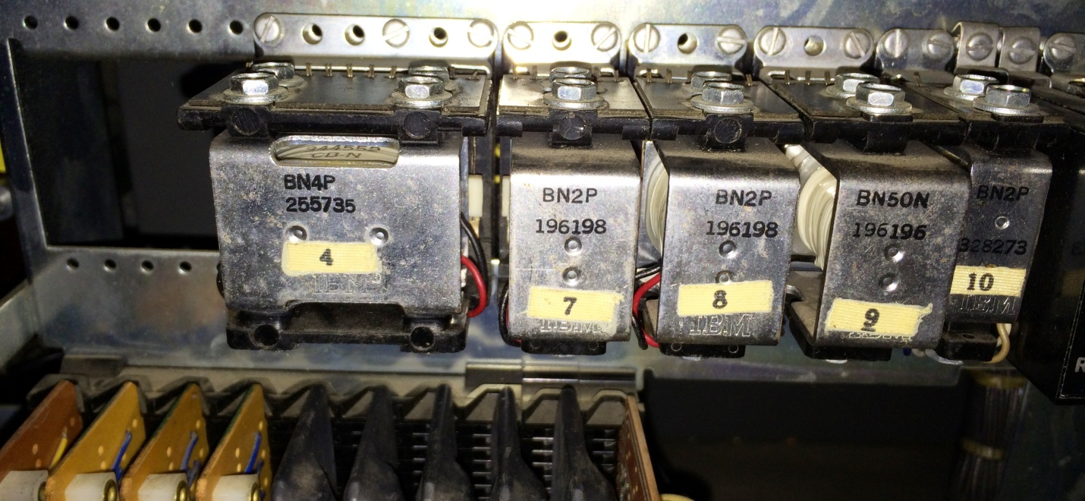

The relay sockets have push pin connectors where various wires are installed. Certain pins will be pulled out of the original hole and pushed into a new hole, moving the wire to that new location. The relay sockets have a standard layout, as viewed by a person looking from behind the keypunch and downward onto the back of the logic gate.

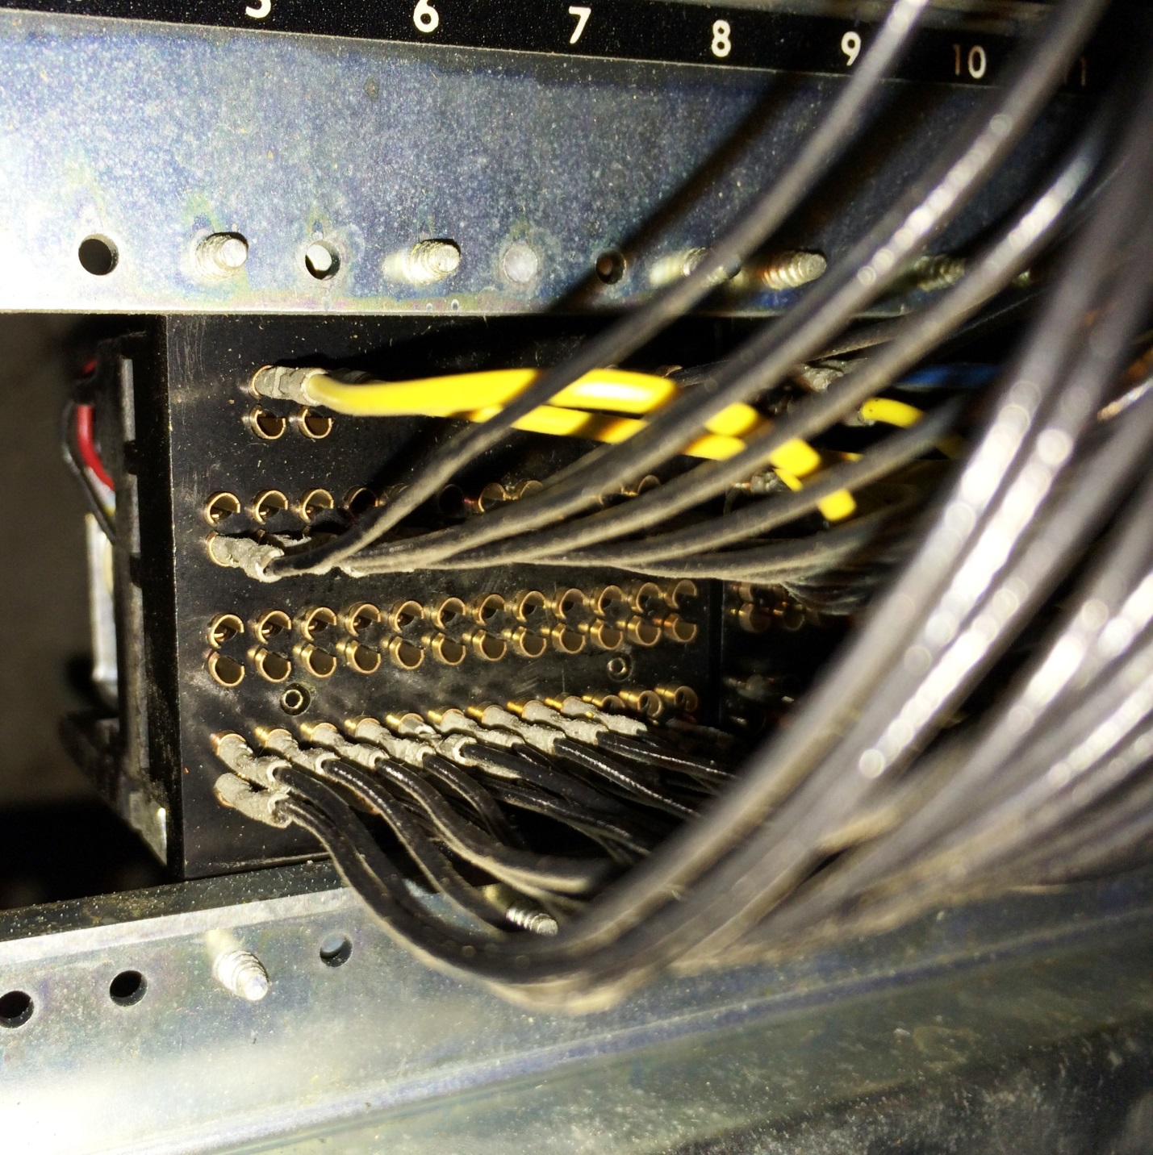

All the connections on the relay socket consist of a pair of holes. At the top are two pairs (four holes) that connect to the coils which energize and hold the relay activated. The next row are the normally open contacts, those that are connected to the pole only when the relay is energized. Continuing down we find the normally close contacts, which are connected only while the relay is not activated. Finally, across the bottom, are the pole contacts which are connected to either N/O or N/C depending on whether the relay is energized.

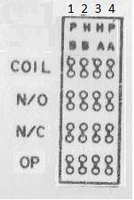

Relay as seen from socket side

We start with the DUP1 relay (number 7) which has six sets of contacts numbered 1 to 6 from left to right. We will change the wires connected to the number 5 set only. We take off the wire from the pole contact of set 5, connected it to the N/O contact of set 5. The wire that was originally connected to N/O of set 5 is moved to the pole contact set 5.

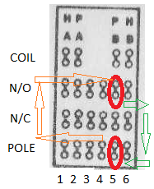

Swap wires for contact set 5

Next, we swap the N/O and POLE wires on all twelve sets of contacts on the DUP3 relay (number 4).The two modifications put the sensing/reading mechanism of the read station on the POLE contacts of both relays, so that the reading mechanism can be switched between the keypunch use for duplicating and the new interface use for reading.

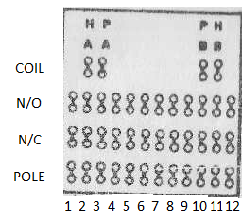

Swap all 12 sets of wires between N/O and POLE

Cabling to the keypunch circuitry

Connections are added from the new interface control box to the logic gate of the keypunch, all connected to the back of the sockets where the connectors (PCBs terminating wires) hook cables from the rest of the machine into the logic gate.

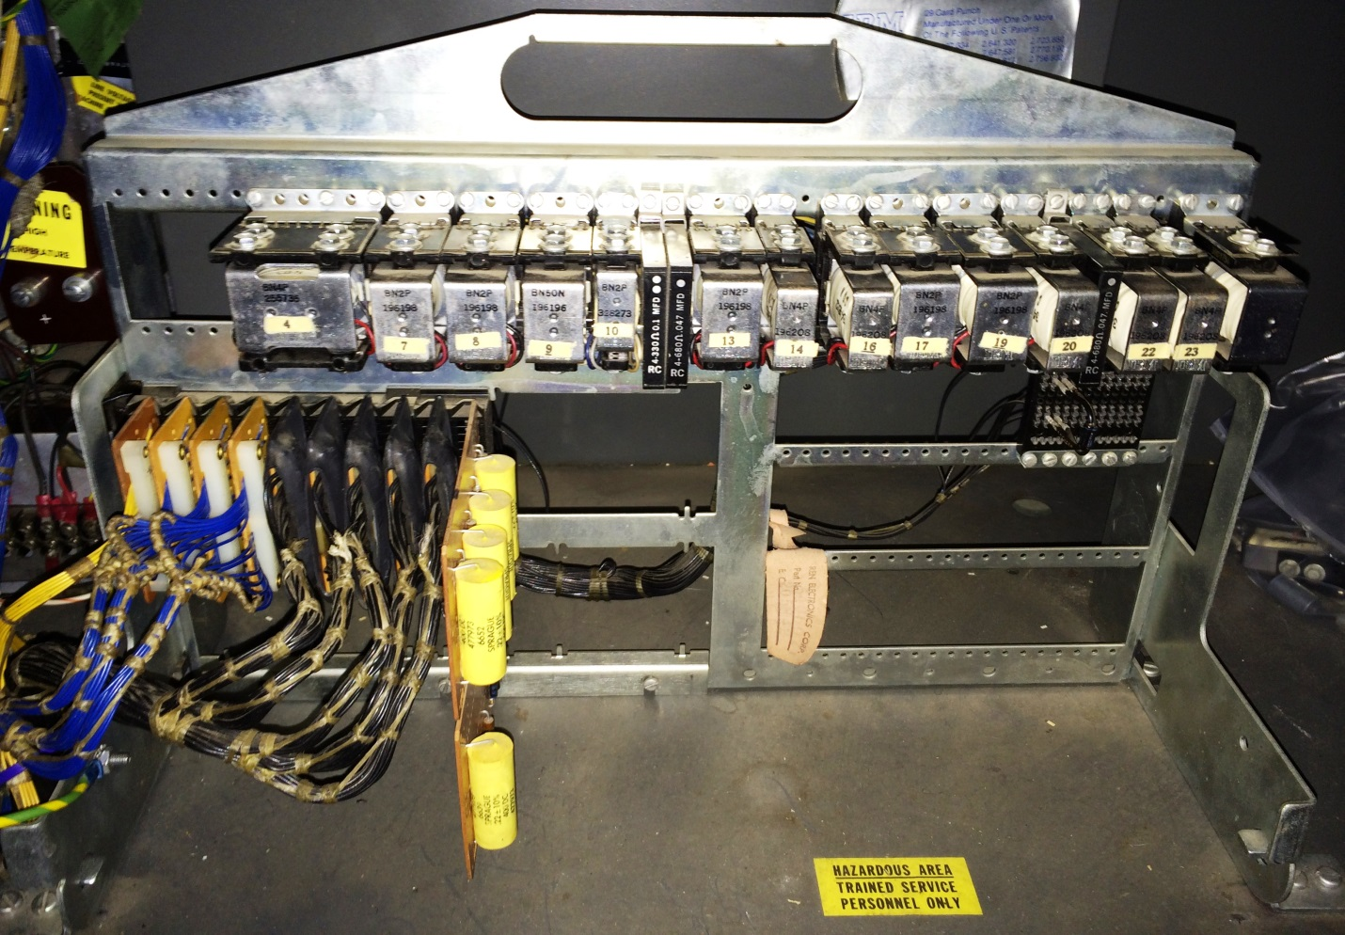

The interface box has two DB-25 connectors on it, one male and one female, for connection to the keypunch logic gate. One provides the main punching and control connections (called Punch Cable), the second is added when reading and/or verification of cards is desired (named Read Cable).

The Punch Cable is hooked to positions on the back of the SMS connector panel on the logic gate. Looking at the gate in its normal position, perpendicular to the floor, we see a set of cables, each with a short printed circuit card on the end, that are plugged into the SMS connector panel.

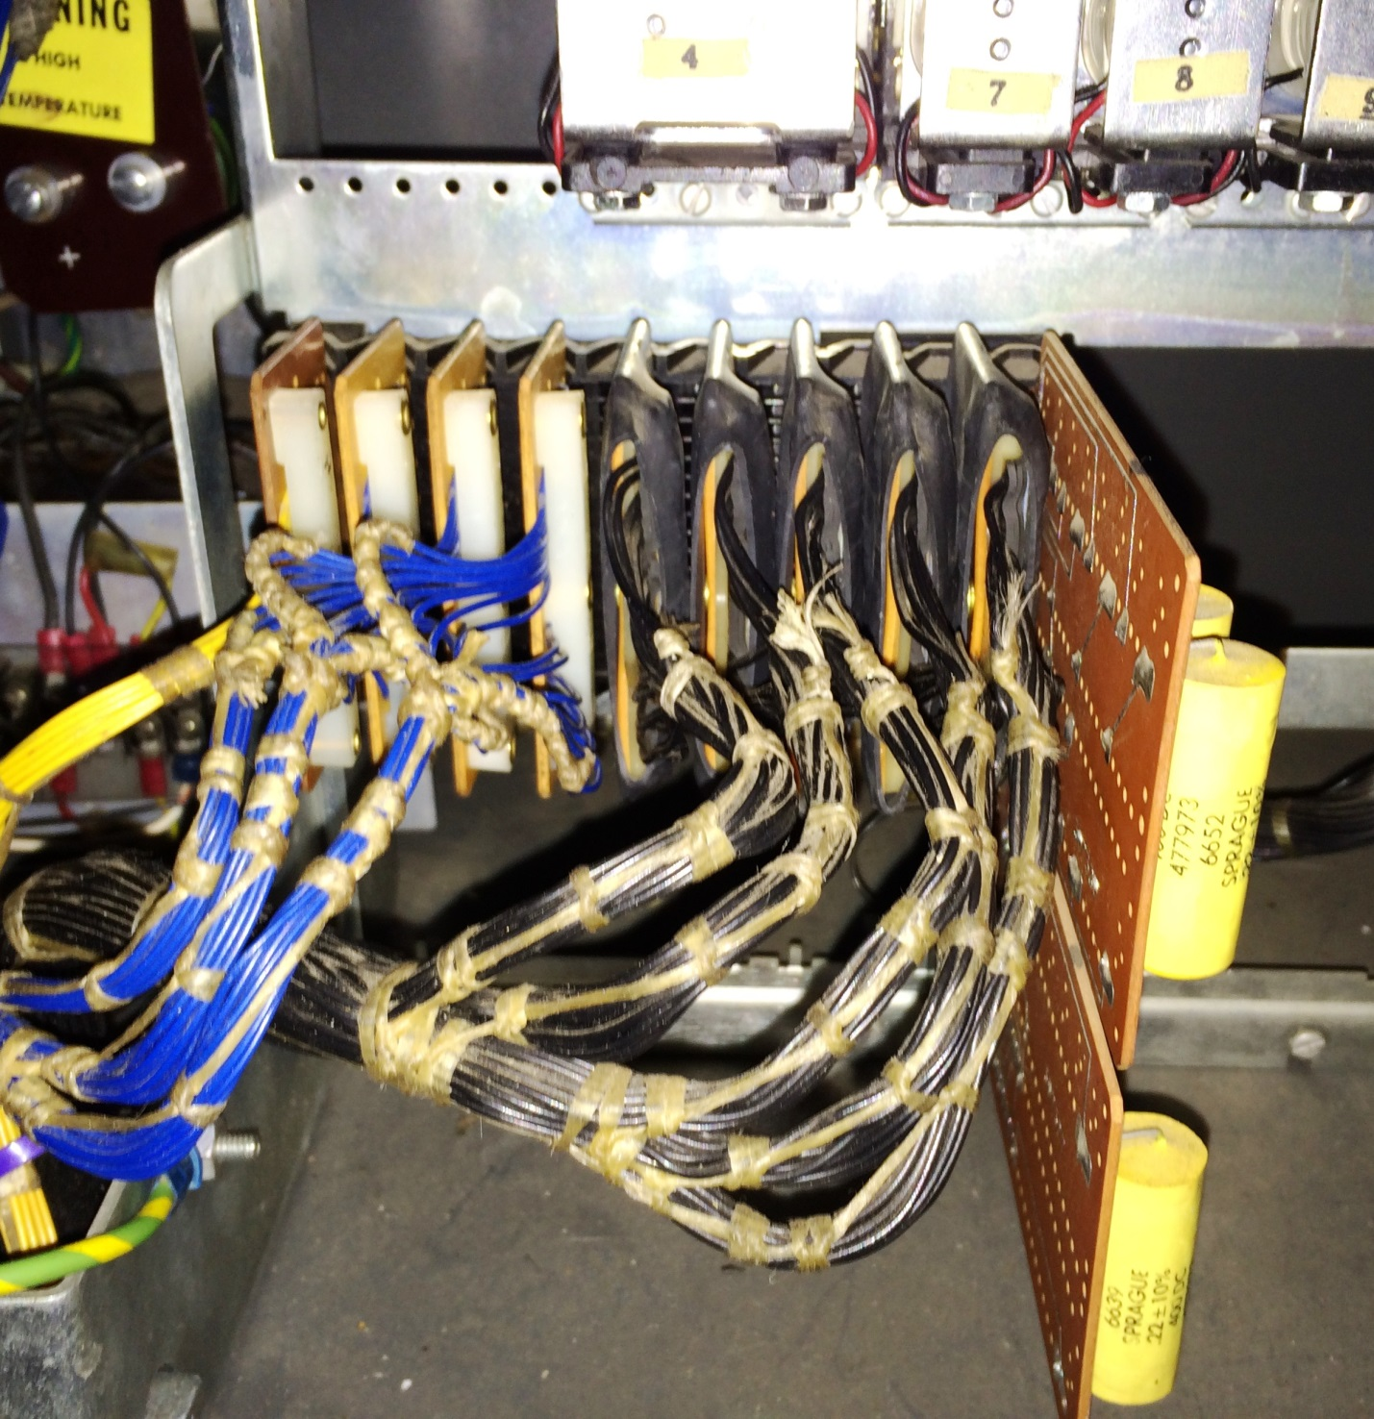

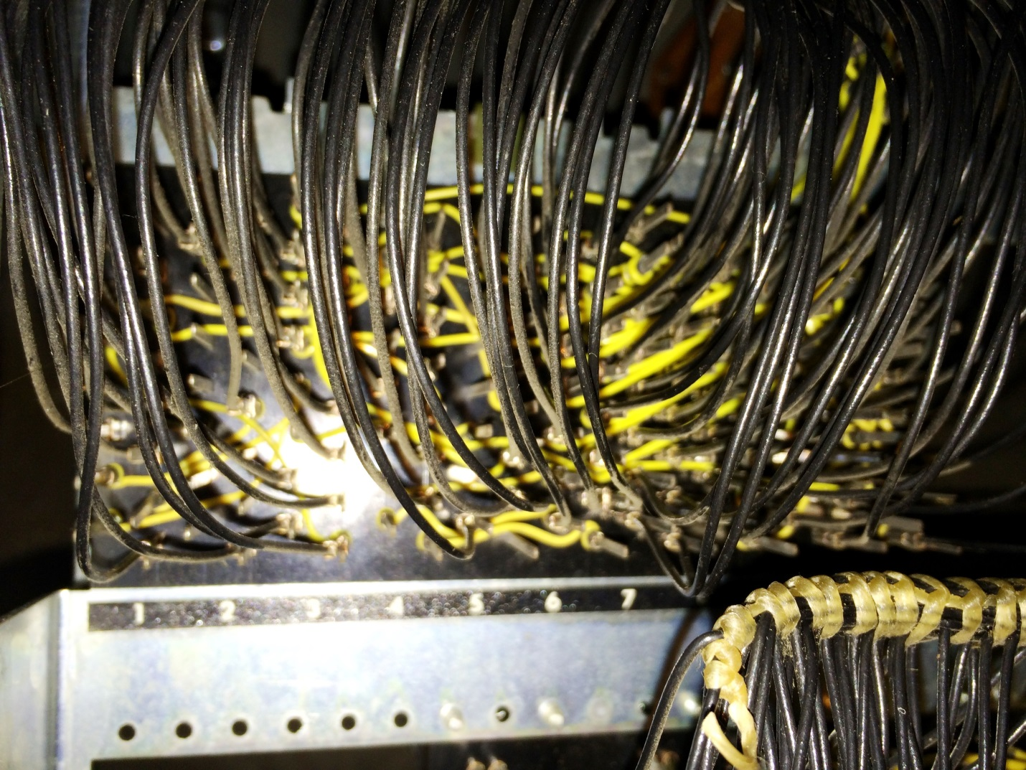

To accomplish the wiring, it is easiest to buy a single DB-25 cable, at least six foot length, that has a male connector on one end and a female on the other. It is important that this be a straight through cable with all 25 connections on each connector. Some cables intended for RS232 serial ports cross wires and use only the contacts relevant to mainstream serial links.

Cut the cable so that you have a three foot section of cable with a connector on each end. The cable with the male connector is the Punch Cable, the other one will be the Read Cable. Wiring the second cable is only needed if f you want the added functionality of reading cards or verifying that prior card punched at the same time as the current card is punched.

Wiring of the punch cable

This cable uses 24 wires out of the 25 in the cable, with specific pins on the connector assigned to certain signals. These wires are connected to the logic gate of the keypunch, hooked to either the SMS panel or the relay sockets. After they are connected, the cable should be neatly dressed with cable ties or lacing cord to avoid them snagging on other objects in the future as the gate is opened and closed.

The 12 rows and the space wires are connected to the A06 slot on the SMS panel:

* 12 punch to A06 B and is pin 12 of the Punch Cable, wired to Arduino pin 25
* 11 punch to A06 C and is pin 11 of the Punch Cable, wired to Arduino pin 24
* 0 punch to A06 D and is pin 10 of the Punch Cable, wired to Arduino pin 23
* 1 punch to A06 E and is pin 9 of the Punch Cable, wired to Arduino pin 22
* 2 punch to A06 F and is pin 8 of the Punch Cable, wired to Arduino pin 52
* 3 punch to A06 G and is pin 7 of the Punch Cable, wired to Arduino pin 53
* 4 punch to A06 H and is pin 6 of the Punch Cable, wired to Arduino pin 50
* 5 punch to A06 J and is pin 5 of the Punch Cable, wired to Arduino pin 51
* 6 punch to A06 K and is pin 4 of the Punch Cable, wired to Arduino pin 48
* 7 punch to A06 L and is pin 3 of the Punch Cable, wired to Arduino pin 49
* 8 punch to A06 M and is pin 2 of the Punch Cable, wired to Arduino pin 46
* 9 punch to A06 N and is pin 1 of the Punch Cable, wired to Arduino pin 47
* Space to A06 A and is pin 13 of the Punch Cable, wired to Arduino pin 26

The common connection for the punches is hooked to A03 B on the SMS panel and is pin 15 of the Punch Cable. This is 48V available only when a card is registered and it is okay to punch

48V constant voltage is sourced by connecting to A08 E on the SMS panel and is pin 20 of the Punch Cable.

The release relay in the interface box is pin 14 of the Punch Cable, , wired to Arduino pin 27 and connects to A02 R SMS contact.

The multi-punch relay lines are hooked to A03 L and A03 M SMS contacts and are pins 18 and 19 of the Punch Cable, wired to Arduino pin 28.

The card registered status circuit is connected to pins 16 and 17 of the Punch Cable, wired to Arduino 5V supply and pin 44, and hook to a reed switch that is placed alongside the coil of relay 24 (Card Lever), aligned with the axis of the coil. Secure this with a cable tie around the relay.

Wires 23 and 25 of the punch cable are soldered together to act as a test from the Arduino to verify the cable is connected, wired to Arduino pins 42 and 43.

A dummy punch cycle is initiated by Arduino pin 29 to wire 21 of the punch cable, hooked to A06R

A heavy ground wire is hooked to the power supply ground and brought into the interface box to hook to the arc suppression diodes.

Wiring the read cable to the keypunch

The Read Cable hooks to DUP3 relay N/C contacts at the relay panel:

* Row 12 is wired to contact set 1, A02A, and is pin 1 of the cable
* Row 11 is wired to contact set 2, A02B, and is pin 2 of the cable
* Row 0 is wired to contact set 3, A02C, and is pin 3 of the cableh
* Row 1 is wired to contact set 4, A02D, and is pin 4 of the cable
* Row 2 is wired to contact set 5, A02E, and is pin 5 of the cable
* Row 3 is wired to contact set 6, A02F, and is pin 6 of the cable
* Row 4 is wired to contact set 7, A02G, and is pin 7 of the cable
* Row 5 is wired to contact set 8, A02H, and is pin 8 of the cable
* Row 6 is wired to contact set 9, A02J, and is pin 9 of the cable
* Row 7 is wired to contact set 10, A02K, and is pin 10 of the cable
* Row 8 is wired to contact set 11, A02L, and is pin 11 of the cable
* Row 9 is wired to contact set 12, A02M, and is pin 12 of the cable

Common 5V for the read sensors is on pin 13 of the cable and hooks to DUP1 relay contact set 5 N/C

Connect together the wires from pins 19 and 21, which will be tested by the interface to determine whether the optional reader cable has been installed.

The read cable uses 15 of the 25 wires in the cable.

Keypunch diagrams with modifications annotated

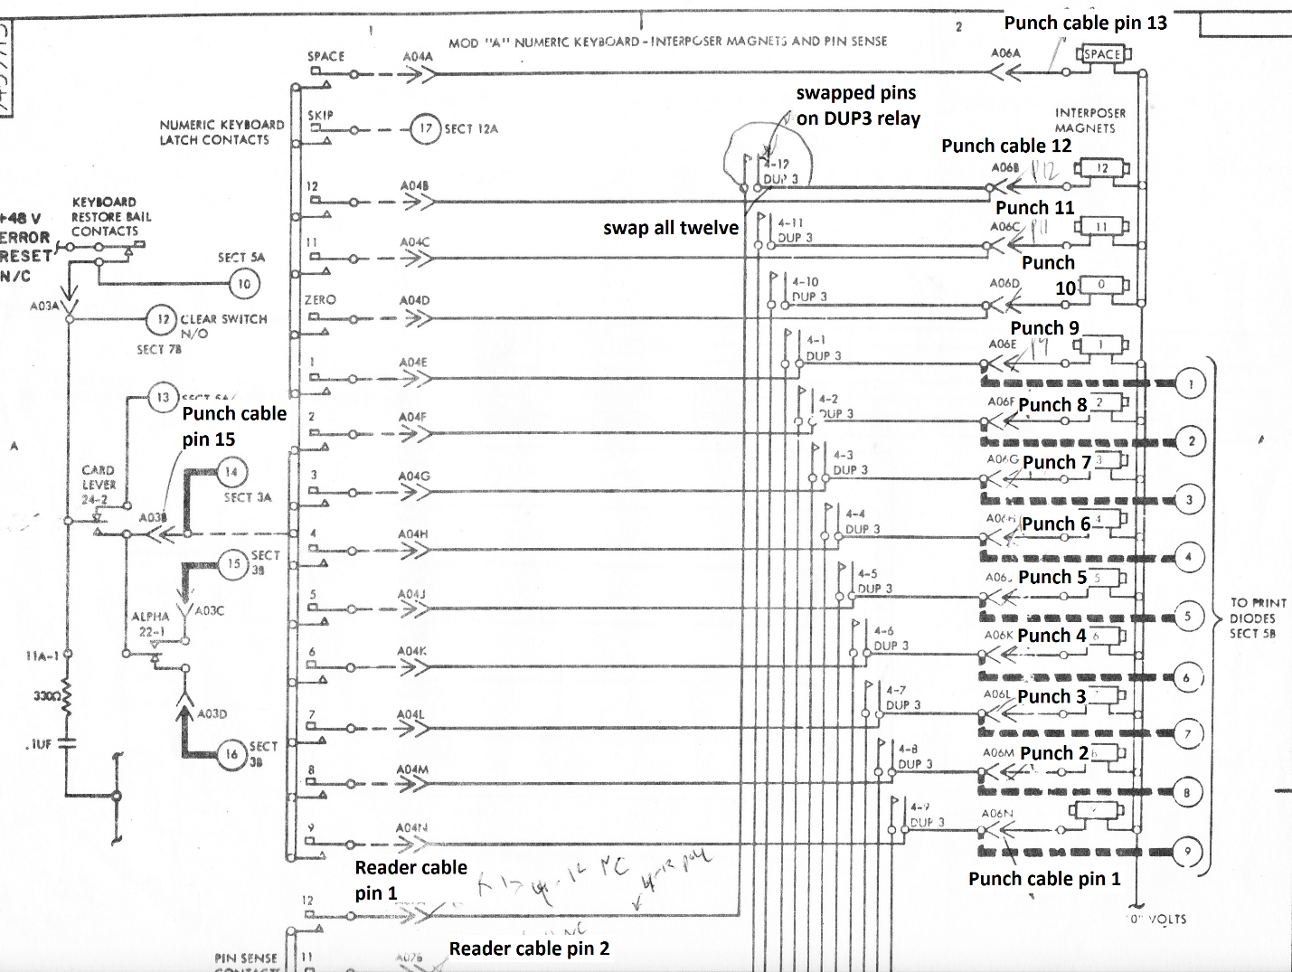

Figure Punch and reader cabling

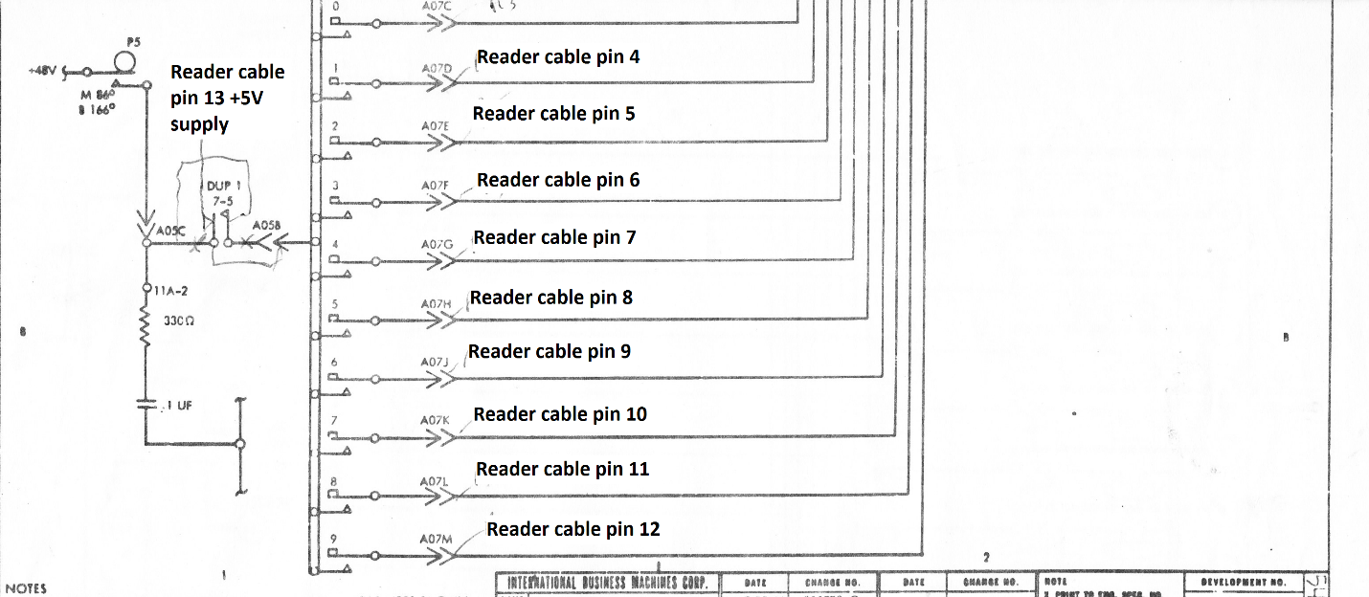

Figure Reader cable connections

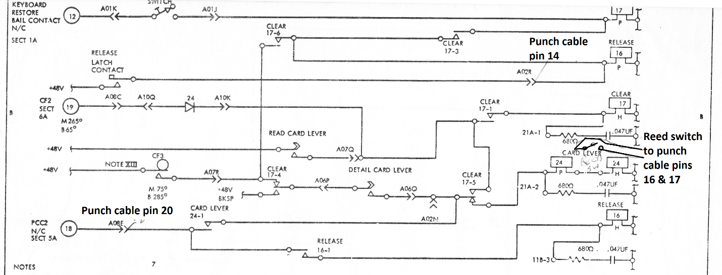

Figure Register reed switch, release and power

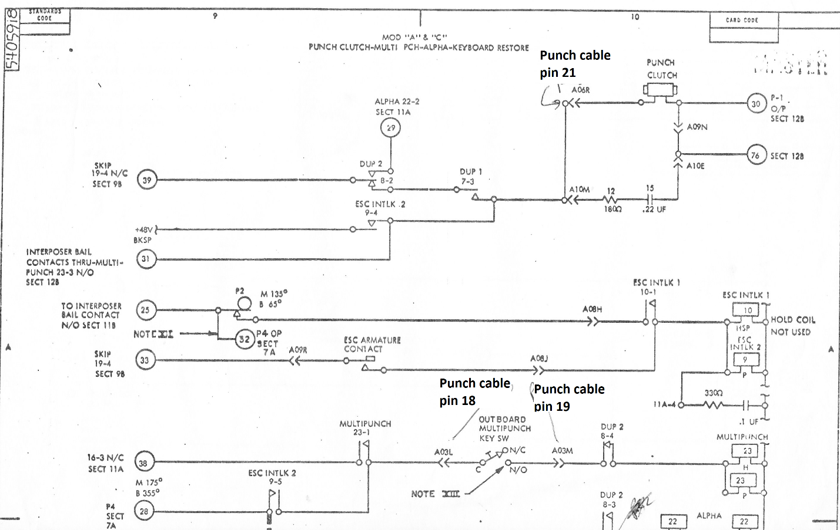

Figure Dummy cycle, multipunch wiring

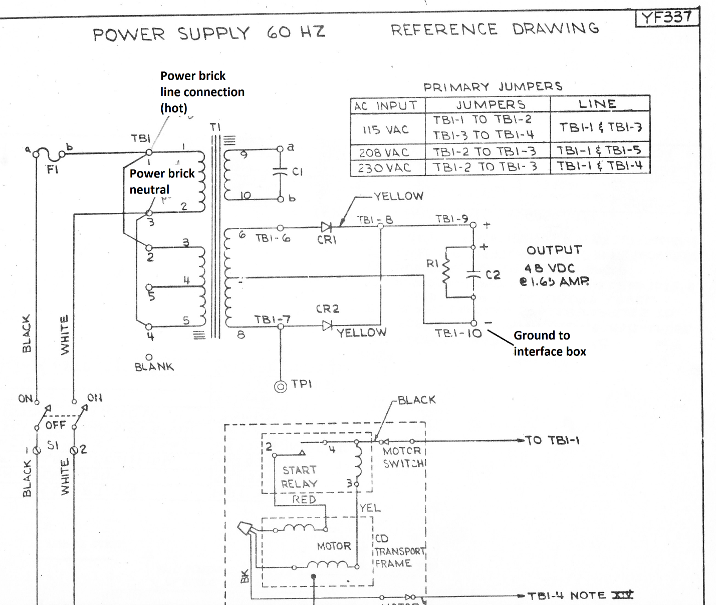

Figure power supply connections

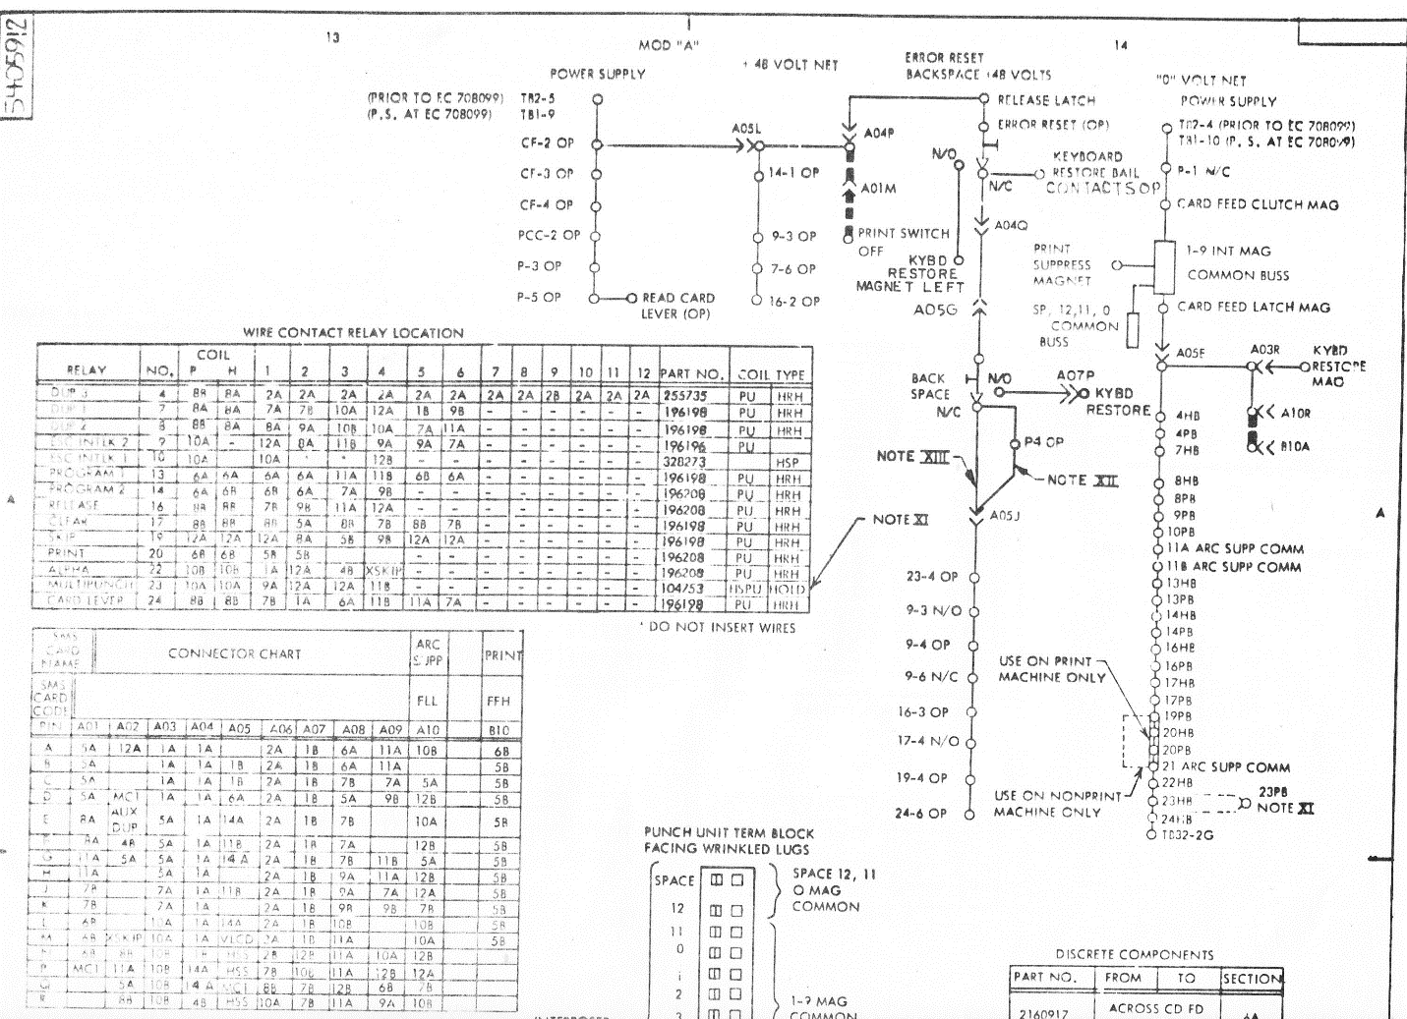

Figure reference material A

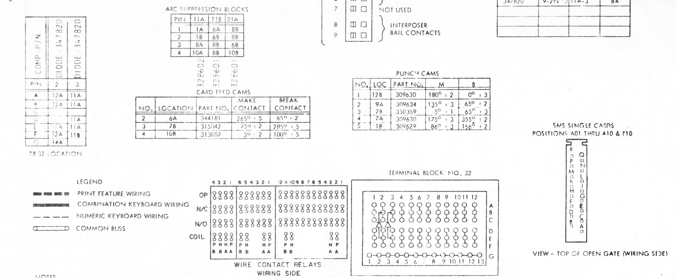

Figure reference material B

Installing interface box in keypunch

Use cable ties to secure the interface box and its cables inside the keypunch but out of the way of the logic gate when it swings open and closed. Two good possibilities are a) the open space on the right of the logic gate, and b) the horizontal tray above the logic gate, which formerly held the reed relay logic before it was superceded by the wire relay logic used on these models.

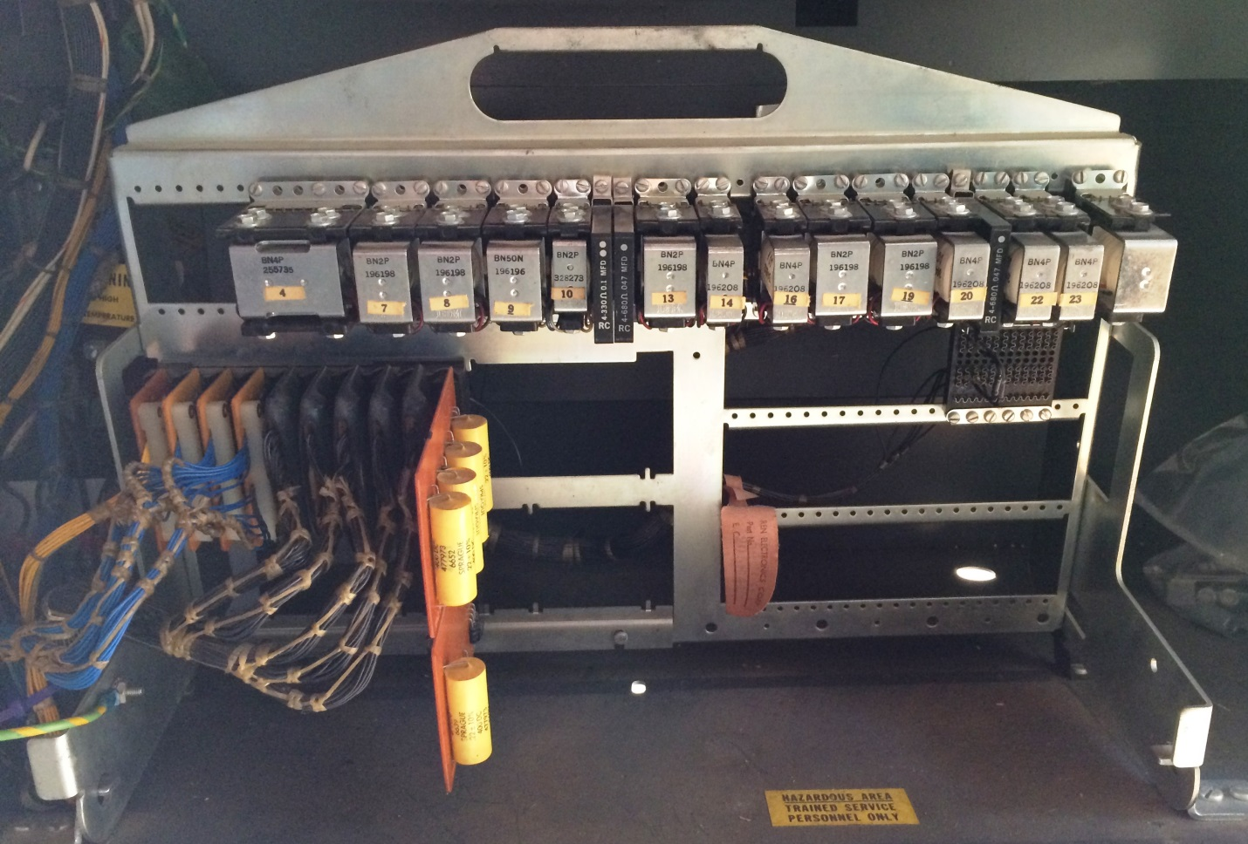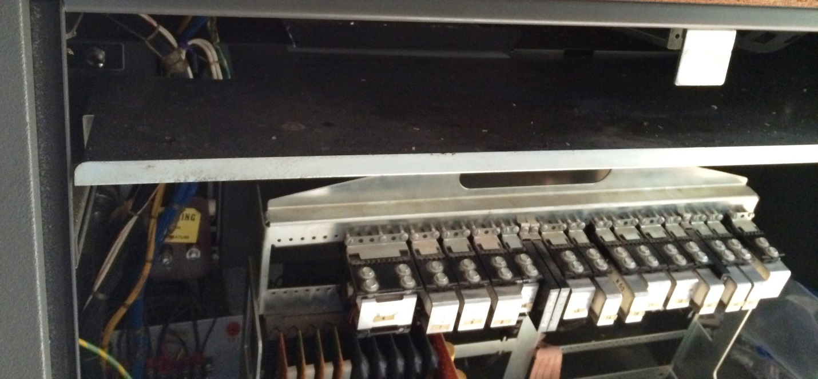

Hooking up power brick to keypunch

The new interface box will receive power from the line power at the power supply when the main switch of the keypunch is on. It should be built with two power leads having lug connectors. These are attached to the keypunch power supply terminal strip TB-1 at positions 1 and 3. TB-1 position 10 is the ground point for the arc suppression wire to the interface.